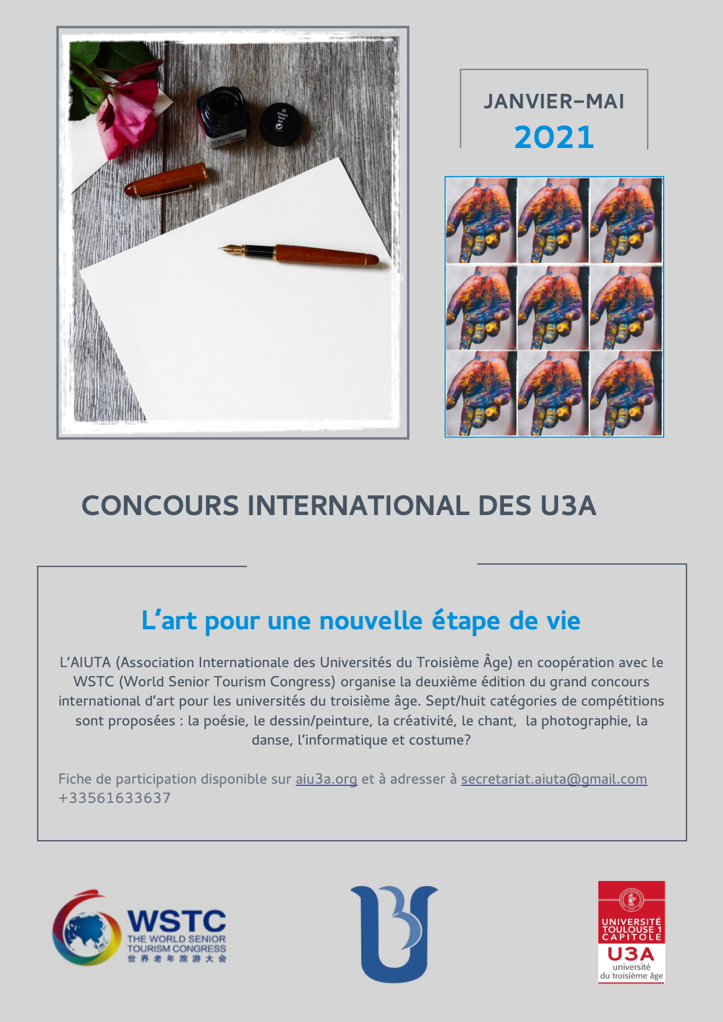

Registration form
U3As International awards - 2021

First name
Last name
Nationality
Country/ City
Email address
Phone number
U3A name
Title of your work

I am registering for U3As competition in the following categories (several choices available- you can enrol in more than one category

Poetry Dancing
Drawing/ painting Costume/fashion

Creativity IT computer/ technology

Singing Photography

Form to be returned before may 31st 2021 to : :
secretariat.aiuta@gmail.com

